Title of the Project: Math formula and shortcut Learning website
Name of the Innovator: Revathi V
Start Date:25-11-2025
End Date: 02-12-2025

Day 1: Empathise & Define
Step 1: Understanding the Need
- Which problem am I trying to solve?
- Adults and students find it difficult to remember and understand math formulas.
- People struggle with lengthy steps and slow problem-solving.
- Many users need shortcuts and visual explanations.
- Who is affected by this problem?
1. School and college students
2. Competitive exam learners
3. Adults who forget fundamental formulas
4. Anyone wanting fast math shortcuts
- How did I find out about this?
- Observation
- Online Research
- AI Tools
Step 2: What is the problem?
People struggle to understand math formulas, memorize them, and apply shortcuts. Most websites only list formulas, but they don’t provide visual animations, step-by-step examples, or easy shortcut techniques.
______________________________________________________________________________________________
Why is this problem important to solve?
Learning math becomes easier when formulas are visual, interactive, and explained using shortcuts. This solves a major learning gap for students and adults who want a fast and simple understanding of mathematics.
_______________________________________________________________________________________________
Take-home task
After discussing with friends and mentors:
Students told me that remembering long formulas and understanding where to use them is the hardest part of math revision. They struggle with algebra, trigonometry, calculus, matrices, and time-saving shortcuts during exams.
Most students said they waste time searching formulas from textbooks, PDFs, or notes. They also pointed out that many websites show formulas in a messy way or without clear steps.

AI Tools you can use for Step 1 and 2:
- ChatGPT: Used to analyze the problem, identify user needs, and refine problem definition.
- Perplexity AI: Used to research learning challenges and existing formula-learning platforms
_____________________________________________________________________________________________
Day 2: Ideate
Step 3: List at least 5 different solutions :
1. Interactive Math Shortcut Website – formulas with animated steps.
2. AI Tutor Bot for Math – explains formulas in simple English.
3. Formula Visualizer – diagrams showing areas, shapes, triangles, matrices.
4. Shortcut Generator – shows quicker solving methods automatically.
5. Formula Quiz System – tests users instantly with feedback.
Step 4: My favourite solution:
My favourite solution is the Interactive Math Formulas & Shortcut Learning Website, which contains formulas, shortcuts, animations, diagrams, examples, and a quiz system.
Step 5: Why am I choosing this solution?
This solution is simple, useful, and accessible. It helps users understand formulas faster using animations and shortcuts instead of long theory. It works for students, adults, and exam-preparing learners.
____________________________________________________________________________________________

Take-home task:

Attach the image in this box below:

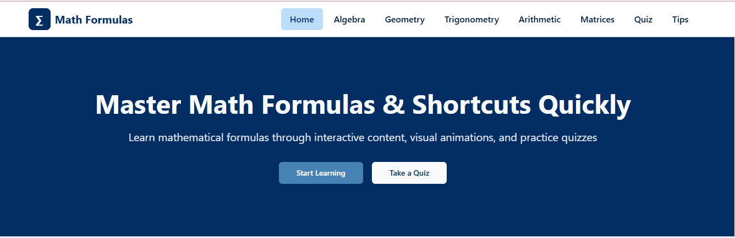

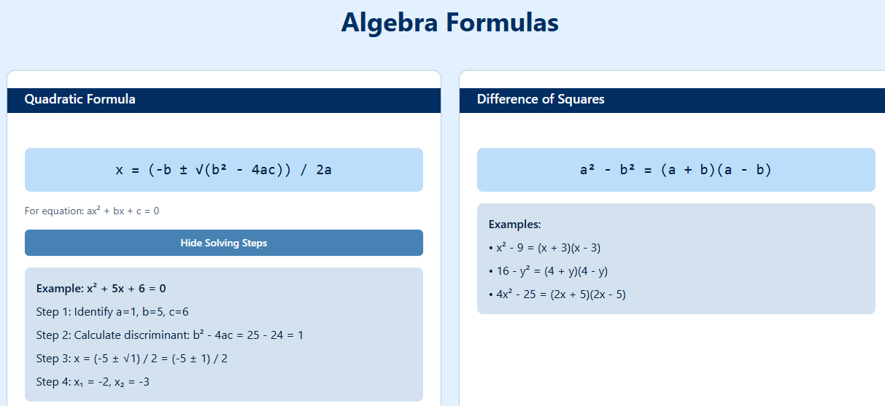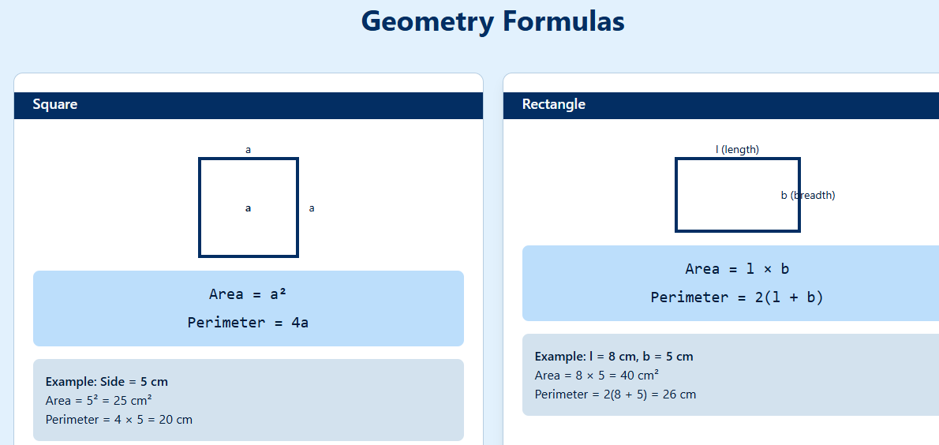

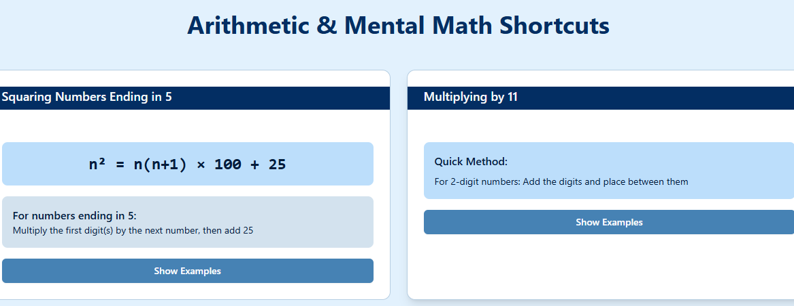
AI Tools you can use for Step 3-5:
1. ChatGPT – for ideas, formulas, shortcuts, content
2. Perplexity AI – for research
3. Meta AI: Use these mobile-based tools to generate images for the solution they want to design
_____________________________________________________________________________________________
Day 3: Prototype & Test
Step 6: Prototype – Building my first version
What will my solution look like?
A website with a clean interface where users can view formulas category-wise, explore animations, check shortcut steps, and practice quizzes.

Pages & Formulas Included:

1.Home Page
- Light blue background
- Title: “Master Math Formulas & Shortcuts Quickly”
- Navigation: Algebra | Geometry | Trigonometry | Arithmetic | Matrices | Quiz | Tips
_________________________________________________________________________________

2. Algebra Page

Quadratic Formula
x = (–b ± √(b² – 4ac)) / (2a)

Factorization
a² – b² = (a + b)(a – b)

Binomial Expansion
(a + b)ⁿ = Use Pascal’s Triangle for coefficients
Examples:
(a + b)² = a² + 2ab + b²
(a + b)³ = a³ + 3a²b + 3ab² + b³

Arithmetic Progression (AP) Sum
Sₙ = n/2 × [2a + (n – 1)d]

Geometric Progression (GP) Sum
Sₙ = a × (1 – rⁿ) / (1 – r)
______________________________________________________________________________________________

Matrices

Matrix Addition / Subtraction
C = A + B
C = A – B

Scalar Multiplication
C = k × A

2×2 Determinant
|A| = ad – bc

Matrix Multiplication (Row × Column)
C(i,j) = (A(i,1) × B(1,j)) + (A(i,2) × B(2,j)) + …
______________________________________________________________________________________________

3. Geometry Page

Square
Area = a²
Perimeter = 4a

Rectangle
Area = l × b
Perimeter = 2(l + b)

Triangle
Area = ½ × base × height

Circle
Area = π × r²
Circumference = 2πr

Pythagoras Theorem
c² = a² + b²

Volume
Cube: V = a³
Cuboid: V = l × b × h
Cylinder: V = π × r² × h

4. Trigonometry Page

Basic Ratios
sin θ = opposite / hypotenuse
cos θ = adjacent / hypotenuse
tan θ = opposite / adjacent

Identity
sin²θ + cos²θ = 1

Angle Sum Formulas
sin(a + b) = sin a cos b + cos a sin b
sin(a – b) = sin a cos b – cos a sin b
cos(a + b) = cos a cos b – sin a sin b
cos(a – b) = cos a cos b + sin a sin b

Special Angles
sin 0° = 0, sin 30° = 1/2, sin 45° = √2/2, sin 60° = √3/2
cos 0° = 1, cos 30° = √3/2, cos 45° = √2/2, cos 60° = 1/2
_____________________________________________________________________________________________

5. Arithmetic / Mental Math

LCM / HCF Trick
Prime factor both numbers →
LCM = take highest powers
HCF = take lowest powers

Square of Numbers Ending in 5
Example: 35²
→ 3 × (3 + 1) = 12
→ Answer = 1225

Fast Multiplication Trick
(a + b)(a – b) = a² – b²
_____________________________________________________________________________________________

6. Matrices Page

Addition
C = A + B

Scalar Multiplication
C = kA

Matrix Multiplication
C(i,j) = Σ (A(i,k) × B(k,j))

2×2 Determinant
|A| = ad – bc

Transpose
Aᵀ = rows become columns

Inverse (2×2)
A⁻¹ = (1 / (ad – bc)) ×
[ d –b
–c a ]
______________________________________________________________________________________________
AI Tools I will need to build this:

Tools Selected
- ChatGPT – For formulas, explanations, and shortcut generation
- Lovable AI – To design and build the website
- Canva AI – To create interface mockups
- Figma AI – For layout and prototyping
- GitHub – For uploading project files

Step 7: Test – Getting Feedback
Who tested?
- Classmates
- Project mentor
👍 What works well:
- Clean layout
- Easy formulas
- Strong visuals
- Useful shortcuts

🔧 What needs improvement:
- Add more examples
- Include step-by-step practice problems

Take-home task
I recorded my project explanation and uploaded them along with images and the website model on GitHub.
What I uploaded:
• Full project report explaining the Math Formulas & Shortcut Website
• Screenshot images of all the main pages (Home, Algebra, Geometry, Trigonometry, Arithmetic, Matrices, Quiz)
• Images showing the formula shortcuts and explanation steps
• The main project files and website code
• The working website link generated using MEDO Ai
AI Tools used for Step 6–7:
• ChatGPT: Helped in creating formulas, shortcuts, page content, and explanations
• Lovable AI: Used to design and build the website quickly through AI-assisted layout generation
• Medo AI: Used to organize the project report and create the structured write-up for uploading
• GitHub: Used to upload and store the project report, screenshots, and final website files
_____________________________________________________________________________________________
Day 4: Showcase
Step 8: Presenting my Innovation
- Final Project Title: Interactive Math Formulas & Shortcut Learning Website
- Document key points of my presentation:

Problem Statement:

Many students struggle to understand mathematical formulas because textbooks explain them in long, complicated steps. They also find it difficult to remember shortcuts for fast problem-solving. This creates confusion during exams and slows down practice.

My Innovation:
I created a Math Formulas & Shortcut Learning Website using ChatGPT, Lovable AI, and Medo AI.
This website allows learners to:
• View important formulas from Algebra, Geometry, Trigonometry, Arithmetic, and Matrices
• Learn shortcut methods for faster solving
• See animated step-by-step explanations
• Practice using quiz questions
• Understand formulas visually instead of memorizing blindly
It helps students learn formulas quickly and clearly without relying on traditional lengthy notes.

Feedback I Received from Users:
- What works well:
• Clean and simple interface
• Easy explanations of formulas
• Helpful shortcut techniques
• Page-wise categorization makes learning fast
- What can be improved:
• Add more solved examples
• Include video explanations in future updates
• Add a downloadable formula chart
Tested by: My classmates and mentor from my college’s mathematics project team.

Impact of My Innovation:
The Math Formulas & Shortcut Website makes learning faster, easier, and more interactive. It reduces confusion, improves formula recall, and helps students prepare for exams effectively.
It turns difficult formulas into simple visual steps — empowering learners to understand concepts confidently and perform better in mathematics

Step 9: Reflections
- What did I enjoy the most during this project-based learning activity?
Designing animated math explanations and creating visual formula pages. Using AI tools made the development faster and more creative.
- What was my biggest challenge during this project-based learning activity
- Integrating animated steps smoothly and organizing many formulas clearly across pages.

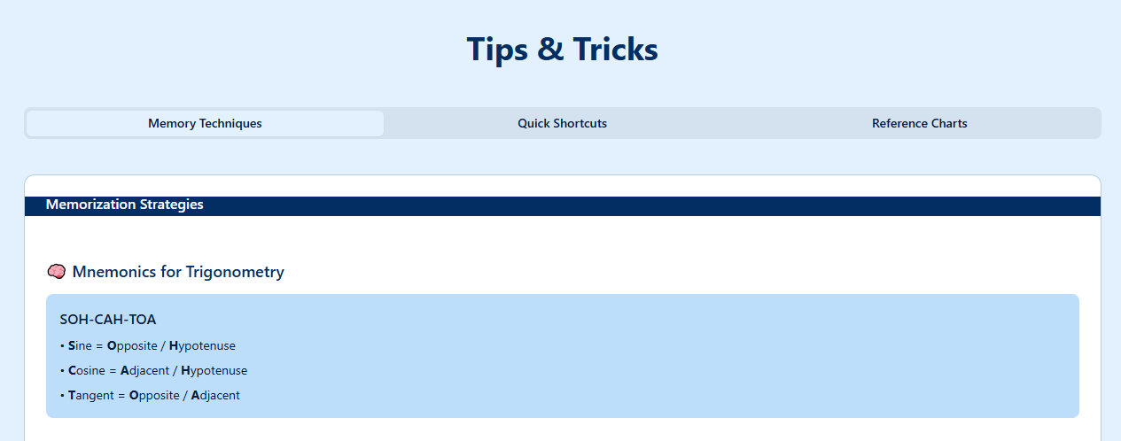

Take-home task
Upload your pitch document on GitHub
PROJECT LINK: https://app-7w306cniv6dd.appmedo.com
GITHUB LINK: https://github.com/Revathi-2006/math-formula-shortcut.git

